Basic Format - Microsoft Word

Open up a new Word document. Hit Ctrl A. In PAGE LAYOUT tab go to Page Setup click corner arrow
Change Bottom to 0.7 then Apply to: Whole document. Click OK
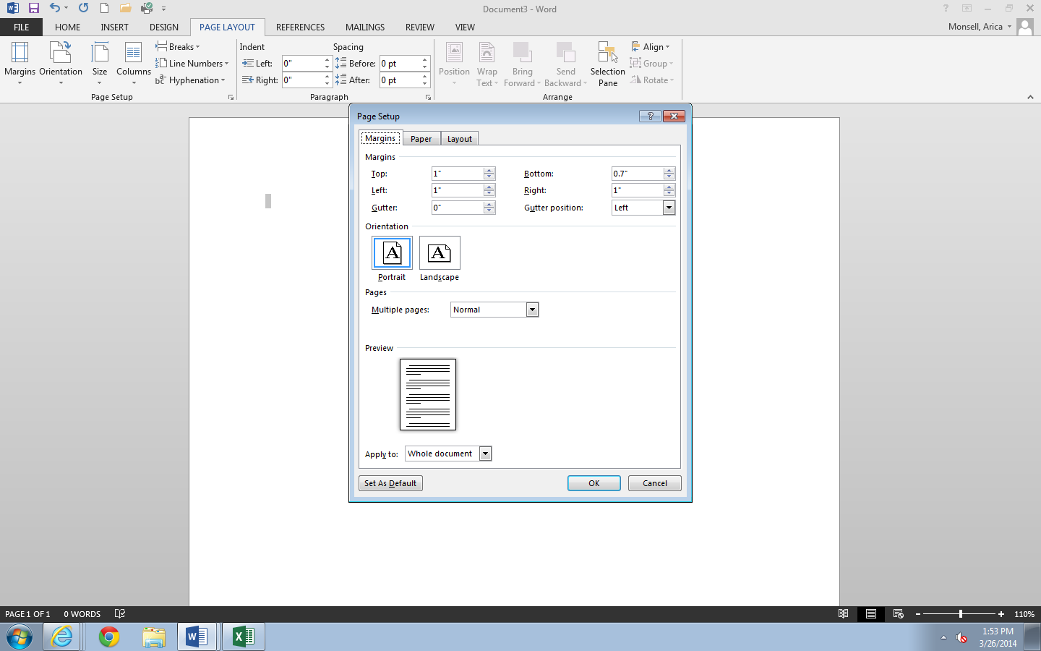

In the HOME tab click on Paragraph corner arrow.
Change Line spacing to Double
Check “Don’t add space…”
Click on Line and Page Breaks tab > Uncheck Widow/Orphan control > click OK
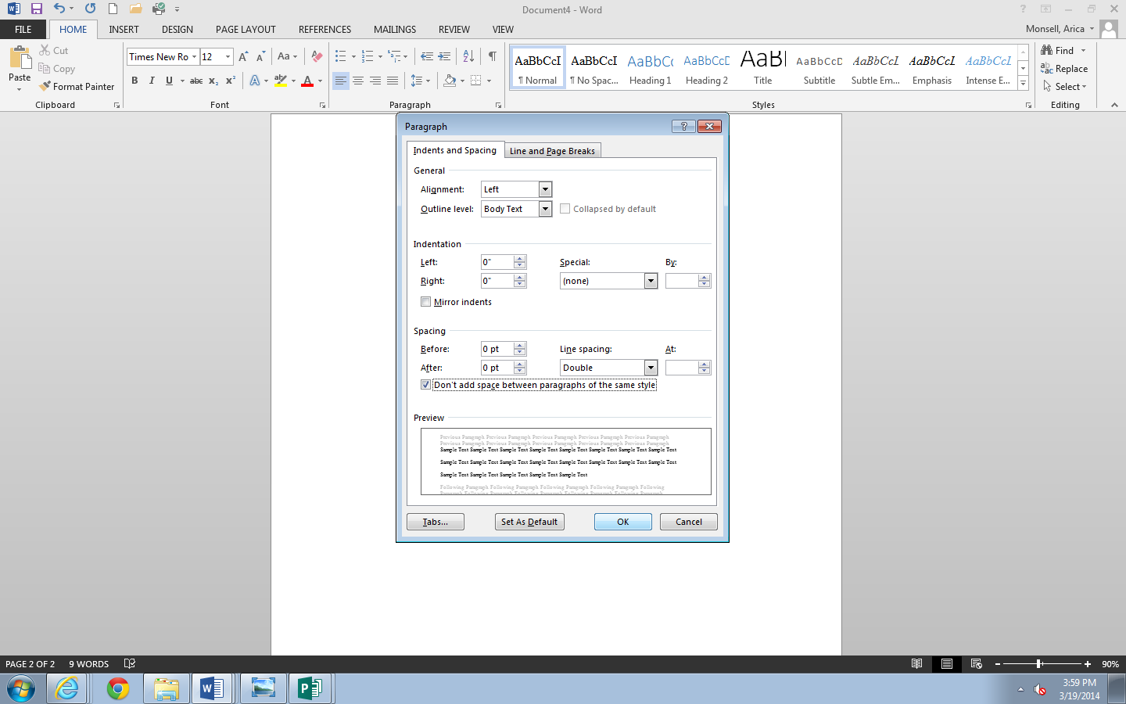

Click on paper

