Reference Page Format

In the HOME tab > Center cursor > Click Paragraph corner arrow > Set Indentation to: (none) > Double Line spacing > Check Don’t add space… > Click OK
Type: References. Hit Enter. Set cursor to Left margin.
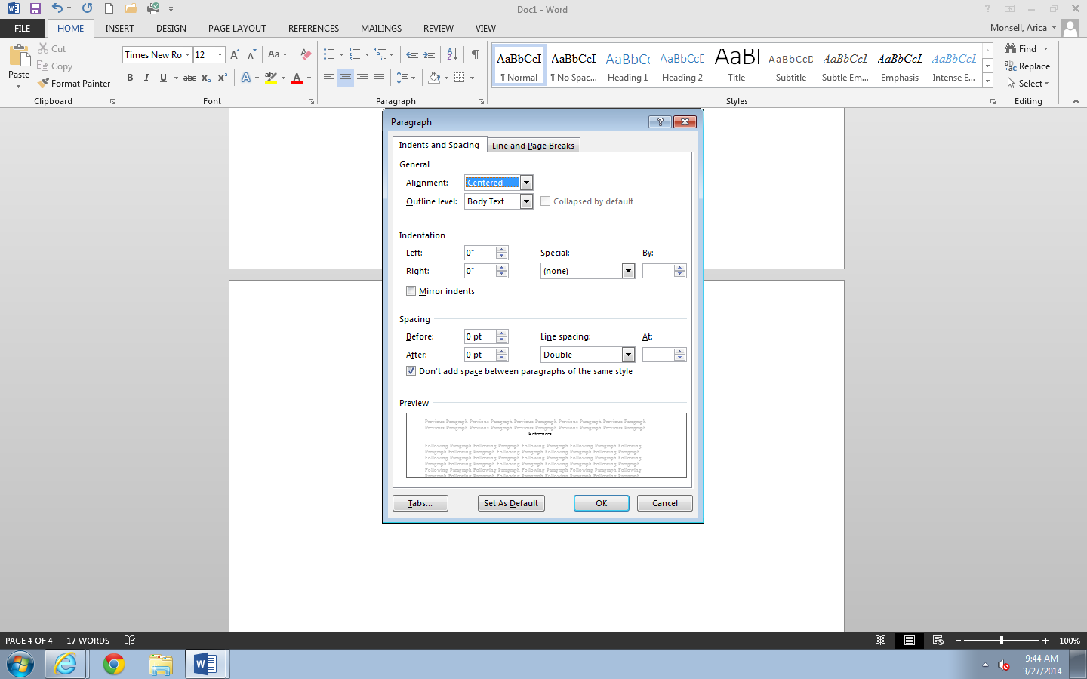

In the HOME tab > Click Paragraph corner arrow > Set Indentation to: Hanging
Click OK
SAVE!
